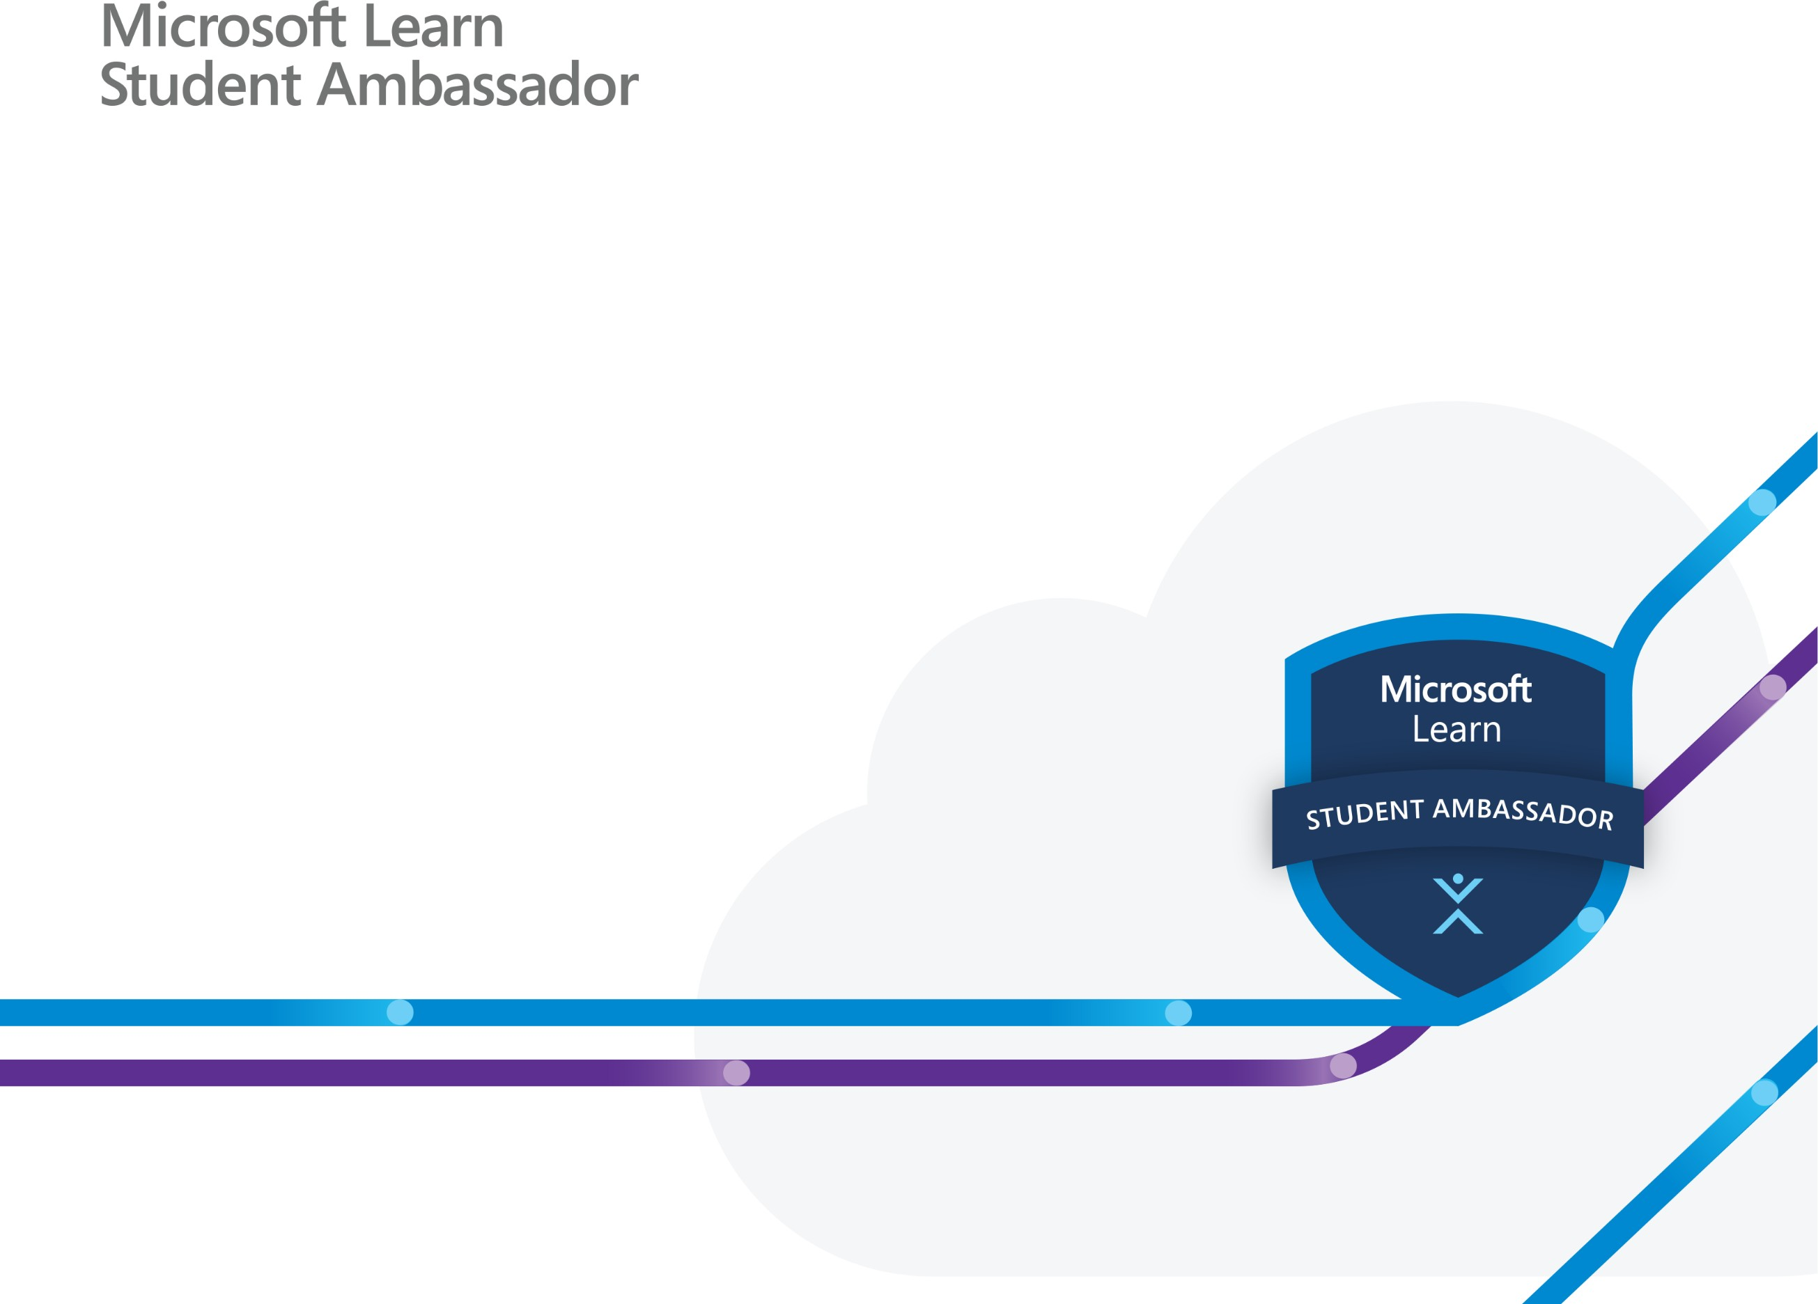

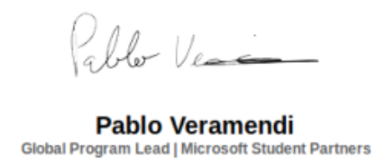

|  |
| --- |
| This certificate is presented to: |
| Koshan Qari |
| In recognition of your attendance and completion of the Microsoft Student Ambassadors Workshop on  {MICROSOFT EMERGING TECHNOLOGIES} |
| A picture containing text  Description automatically generated  Event Hosted By  TAJAMUL ASHRAF  Microsoft Learn Student Ambassador |